ID | Task Name | Assignee | Dur | ES | EF | LS | LF | Slack | Critical?
A | Editorial Calendar | Charlie | 1 | 0 | 1 | 2 | 3 | 2 | No
B | DB Schema Design | Lucy | 1 | 0 | 1 | 0 | 1 | 0 | YES
C | Cloud Environment | Snoopy | 1 | 0 | 1 | 4 | 5 | 4 | No
D | Write Articles | Charlie | 3 | 1 | 4 | 3 | 6 | 2 | No
E | API Development | Lucy | 3 | 1 | 4 | 1 | 4 | 0 | YES
F | Build UI Layouts | Sally | 3 | 0 | 3 | 1 | 4 | 1 | No
G | Input Tech Specs | Charlie | 2 | 4 | 6 | 4 | 6 | 0 | YES
H | Stripe Payments | Snoopy | 2 | 1 | 3 | 5 | 7 | 4 | No
I | API/UI Integration | Sally | 2 | 4 | 6 | 4 | 6 | 0 | YES
J | Final QA & Launch | All | 1 | 6 | 7 | 6 | 7 | 0 | YES

Part A – CPM Explanation
Pixel Pulse is an online gaming magazine dedicated to archiving retro gaming. The Team building it includes the Editor and Chief, Ellie, the Frontend Developer Sally, the Writer Charlie, the Backend Developer Lucy and the Dev Ops Specialist Snoopy. The goal is to build an online subscription based magazine set up through Stripe’s payment API.

The Critical Path based on the CPM Chart is 7 weeks, this contains no slack and focuses on the main implantation
Analysis:
The most notable constraint is week 5 and 6 where both the input of tech specs into the database by Charlie and Sally’s integration of the UI and API run parallel with no slack. Delays in either of these will stall the project. There is significantly more slack in the dev ops platform, allowing them to move into later weeks if they become delayed.
Part B - CPM vs PERT
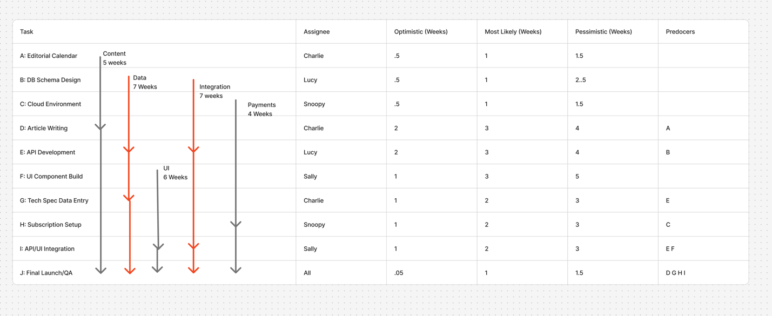 Time Estimation: CPM was more useful than PERT in that it gives a focus single number, instead of focusing on realistic, pessimistic and optimistic, that said it doesn’t consider changes or unknowns. Engineering is messy and sometimes things change these hardlines, the pessimistic and optimistic times allow for that.
Focus: CPM is more focused on defining resource management and identifying specific bottlenecks, while PERT is more based on showing variance and managing uncertainty.
Best use: CPM is better for predictable and rigid projects, for more unknown projects PERT is better.

Part C - CPM vs GNATT
Task | Assignee | Duration | Start | End | Dependencies
Editorial Calendar | Charlie | 1 Week | Week 1 | Week 1 | None
DB Schema Design | Lucy | 1 Week | Week 1 | Week 1 | None
Cloud Environment | Snoopy | 1 Week | Week 1 | Week 1 | None
Article Writing | Charlie | 3 Weeks | Week 2 | Week 4 | Editorial Calendar
API Development | Lucy | 3 Weeks | Week 2 | Week 4 | DB Schema
UI Component Build | Sally | 3 Weeks | Week 2 | Week 4 | None
Tech Spec Data Entry | Charlie | 2 Weeks | Week 5 | Week 6 | API Dev
Subscription Setup | Snoopy | 2 Weeks | Week 5 | Week 6 | Cloud Env
API/UI Integration | Sally | 2 Weeks | Week 6 | Week 7 | API Dev, UI Build
Final Launch/QA | All | 1 Week | Week 8 | Week 8 | All Tasks

Information: CPM focuses on slack and the relationship between different parties, while gnat is more focused on a calendar. When you overlay CPM onto Gnatt it creates a view that allows the PM to see exactly how much projects can slip while still being on time.
Visualization and Use: admittedly all 3 charts were built out as tables, and I am not sure that is the best way to visualize these, that said they both create different views, possibly building them together into one larger chart in a tool like Figjam might be the most useful outcome.

Part D – Reflection
I feel each chart has a specific area which it excels:
PERT – This is best for calculating risk, keeping in mind the human factor and the fact that there is a degree of uncertainty.
CPM – This is best for giving a clear path and showing exactly where progress is most bottlenecked, it is good for dividing resources and allowing for slack in more complex parts of the project.
Gnatt – Gnatt is best for an over view, of mapping out a clear timeline and showing if everything is moving along schedule.
The biggest challenge with CPM is that it doesn’t allow for more natural development, it sees things as very ridged that is why I think the best approach is a hybrid of all three methodologies.

